Planck’s Constant

Equipment Needed

Dell Laptop Computer
AC Adapter, Dell Laptop
Planck’s Constant Apparatus, Cenco 32516
Light Source, Mercury Sci. Kit Bor. Lab. 65895
Jack, Table (Blue)
Multi-meter, Digital (DMM) (2)
Probes, for Multi-Meter, Digital (2)

Figure 1—Set Up and Equipment
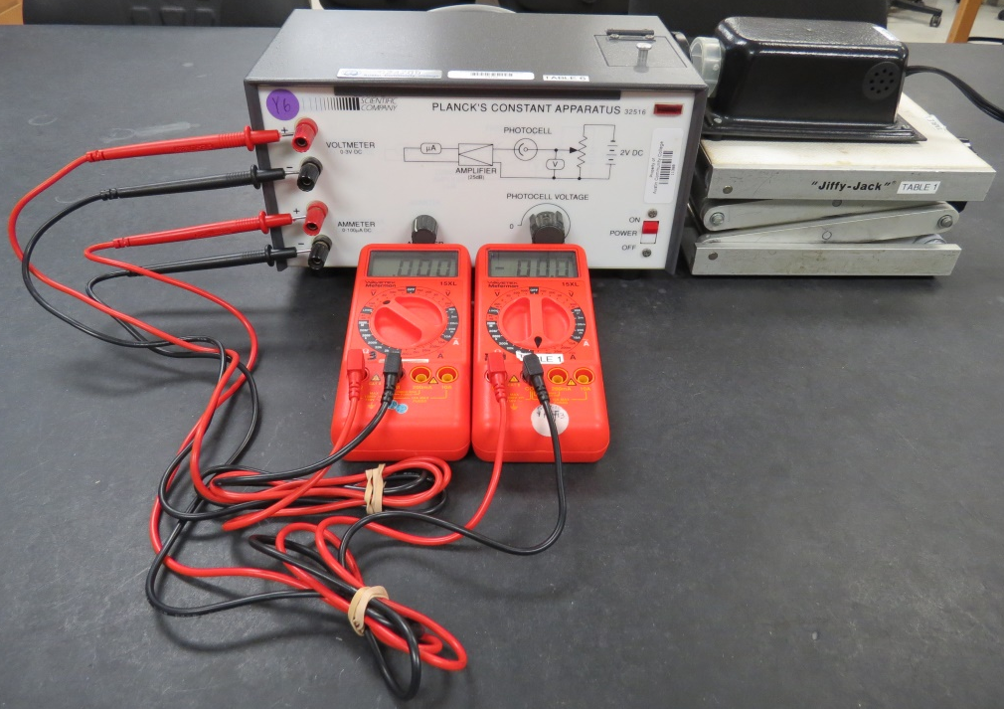

Warning
The Mercury Light Source: Do no look directly at the bulb itself without the translucent or colored filters in place.
Introduction
In 1900, Max Planck developed a theory of the spectrum of light emitted by a ‘black body.’ In order to explain the spectra, Planck postulated that the oscillators comprising the body oscillated at discrete frequencies, and the energy of each oscillator was proportional to the frequency of vibration. In modern notation, Planck’s relationship is given by
where
f is the frequency of the oscillation
n is some integer
h is a constant known as Planck’s constant
The h has a value
Albert Einstein adapted Planck’s idea in 1905 to explain a phenomenon known as the photoelectric effect.
The photoelectric effect was first discovered by Hertz in his experiments to investigate Maxwell’s theory of electromagnetic radiation. When ultraviolet light shined on a cathode, a cathode ray (stream of electrons) was emitted. This effect was investigated carefully by Millikan, and the following general observations were made.
- There was a certain cutoff wavelength of light. Wavelengths longer than this cutoff produced no current; wavelengths shorter than this wavelength did produce a current.
- The current was proportional to the intensity of the light.
- There was no observed delay between the light hitting the metal and the emission of electrons.

Although Maxwell’s theory could account for the fact that the current was proportional to the intensity of the light, it could not account for the other two observations.

Einstein explained the phenomenon by assuming that light occurred in discrete packets which had an energy given by
.
He coined the term photon as the name for these packets of energy. We assume that the electrons are bound to the metal by a binding energy given by
.
With this equation Einstein was able to correctly describe the photoelectric effect, and in so doing lay one of the cornerstones of the theory of quantum mechanics. Paradoxically, Einstein never accepted Quantum Mechanics as a correct theory.
In this experiment, we will investigate Einstein’s equation and make a determination of the ratio of Planck’s constant to the charge of the electron.

Procedure
Our apparatus will consist of a self-contained unit, a light source, voltmeter, and an ammeter.

- Examine the Apparatus
Open the door on the top of the apparatus. In the space below
  - Sketch a schematic of the apparatus.
  - Describe the path of the light. Where does it enter, and what does it hit?
  - Once the light has hit the cathode, describe the path the electrons follow.
  - Where is the anode?
  - Between what electrodes is the retarding potential applied?
  - Which of the electrodes has to be at a higher potential?
- Set up
Connect the positive (red) and the negative (black) voltmeter leads to the positive (red) and the negative (black) voltmeter terminals of the main unit. You should be able to use the 2VDC scale. Similarly, connect both of the microammeter leads to the ammeter terminals of the main unit. You should be able to use the 200µADC scale. Place the meters either on top of the unit or on a flat surface to the side. Turn the filter wheel so the desired filter (start with UV-39) covers the entrance to the photocell. Then put the high-pressure mercury lamp in front of the filter wheel and turn it on. Make sure that the light enters the photocell directly and with as little gap between as possible between the lens housing and the filter wheel. (See Figure 1.)

Figure 2—Planck’s Constant Apparatus Nameplate
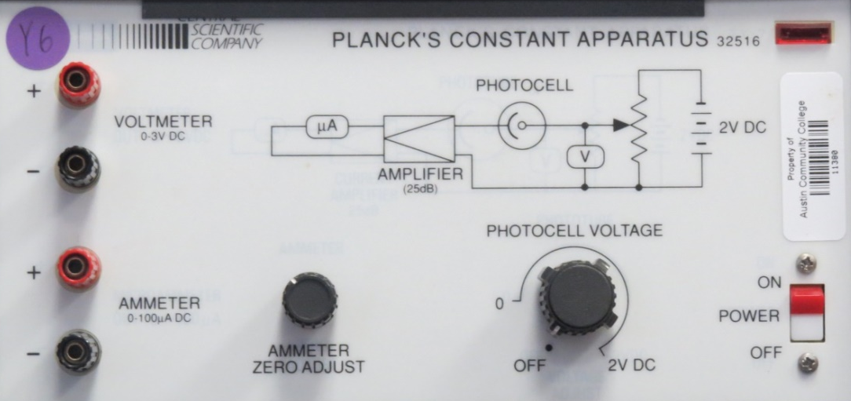

- Initial Setting
Turn the phototube voltage dial to the ‘off’ position. Plug in the main unit and then flip the on/off power switch to the ‘on’ position. Be sure that the pilot light above the power switch is lit before proceeding. Then zero the amplifier output by turning the ammeter zero adjust dial until the micro-ammeter reads . This step eliminates noise interference. Check this zero adjust before taking readings on each of the filters.
- Acquire Data
Turn the phototube voltage dial to the ‘on’ position. By increasing the voltage you will notice that the current begins decreasing. At the point when the current reaches you will take a reading of the voltage. This is the stopping voltage. If you continue raising the voltage you will still have zero current but an erroneous data reading. Remember: the stopping voltage is only at the point where the current just becomes zero. You may even get better data by observing the voltage at . This is a lab technique.
What happened?
When we shined the light on the photocell, we obtained a current. The electrons emitted from the metal have a spread in kinetic energy, up to a maximum potential. We measured the maximum of the kinetic energy by intentionally slowing down the electrons by applying a potential difference, called a retarding potential, opposite the motion of the electrons. As we turned up the retarding potential, the current decreased until it went to zero at a potential that stops the electrons of maximum kinetic energy. The potential at which the current goes to zero is called the stopping potential, denoted . The maximum KE is given by
.
- Get data for the rest of the filters
The experiment then is to vary the frequency of the light by changing the filters allowing light into the cell. For each frequency, adjust the retarding potential until no current is observed, and record the stopping potential. The approximate wavelengths of the prominent mercury lines passed by the filters are in Table 1 below, along with the designation of the filter passing that wavelength.

Table 1: The wavelengths of the Mercury lines used in this lab
Color | Wavelength | Filter Number
Yellow | 579 nm | V-058
Green | 546 nm | V-054
Blue | 436 nm | V-Y43
Violet | 405 nm | UV-39

Table 2: Data Table
Filter Number | Stopping Voltage | Frequency Hz
V-058
V-054
V-Y43
UV-39

Data Analysis
In this experiment, we will examine the Einstein equation
.
The maximum kinetic energy is obtained from the stopping potential, , using the relationship
.
If we plug this expression for the maximum kinetic energy into the Einstein Equation, we obtain
.
Solving for , we obtain
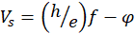.
Thus, when we graph vs. , we will obtain a straight line, with slope of 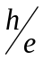
and y-intercept . Calculate the frequencies for the wavelengths given in Table 1. Be careful about the units. Construct a graph of vs. . MS Excel® works well for this. Use the scatter graph and determine the best-fit slope and y-intercept. Don’t forget the units. From your slope and the textbook value of e, determine your value for Planck’s constant. Compute the percent difference between your value and the textbook value of Planck’s constant. Determine the work function for the metal in the cathode. Figure 3 shows a typical graphical layout.
Figure 3 Stopping Potential V_{s} vs. Frequency f (Typically, what your graph should look like)
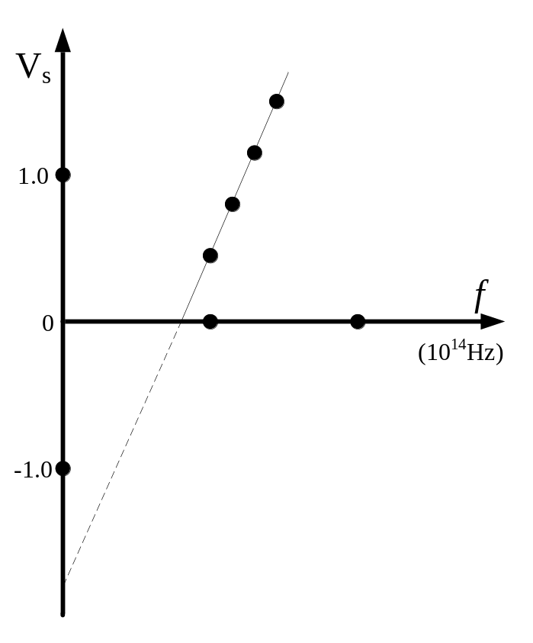

Report Format (Optional)
Turn in your description of the apparatus, graph, and all calculations.
Report the values you have obtained in an organized fashion.

